Policy Name | Conferences, Seminars, Workshops Policy
Proposed By | Director ORIC
Reviewed By | Registrar and Pro-VC
Approved By | ORIC Steering Committee
Effective From | 01-07-2026
Next Review Date | 30-06-2028
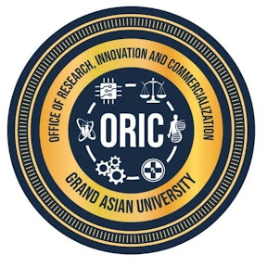
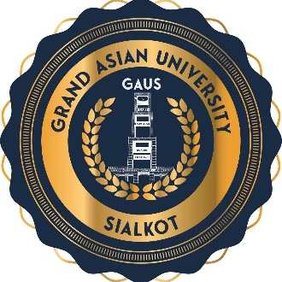
- Preamble
Academic conferences, seminars, workshops, symposiums, colloquia, research exhibitions, and similar scholarly events constitute an essential component of a vibrant research ecosystem. This policy provides a comprehensive framework for the planning, approval, funding, implementation, monitoring, and evaluation of all academic events organized under the University's name.
- Purpose
This policy aims to establish transparent and standardized procedures for organizing academic events that promote research excellence, innovation, knowledge dissemination, professional development, and institutional engagement while ensuring efficient utilization of university resources.
- Objectives
The University shall organize academic events to:
- Strengthen national and international research collaborations.
- Promote industry-academia linkages.
- Build research capacity of faculty members and students.
- Support professional development and lifelong learning.
- Enhance the University's national and international visibility.
- Contribute towards Sustainable Development Goals (SDGs).

- Scope
This policy applies to all academic and research-related events organized wholly or partially under the University's name, whether funded internally or externally.
Category | Minimum Duration | Typical Participants
International Conference | 2–3 Days | International delegates
National Conference | 1–2 Days | National participants
Research Symposium | 1–2 Days | Subject specialists
Seminar/Workshop | Half or Full Day | Faculty & Students
Faculty Development Program | 1–5 Days | Faculty Members
Guest Lecture | 1–3 Hours | University Community
Innovation Expo | 1–3 Days | Academia & Industry
Policy Dialogue | One Day | Policymakers
- Approval Mechanism
No event shall be advertised or announced without formal approval.
Event | Approval Authority
Departmental Seminar | Head of Department
Faculty Workshop | Dean
University-wide Workshop | Pro-VC
National Conference | Vice Chancellor
International Conference | Vice Chancellor with approval of the Competent Authority
- Event Proposal
The organizing department shall submit an Event Proposal containing:
- Background
- Rationale
- Theme
- Objectives
- Expected Outcomes
- Program Schedule
- Organizing Committee
- Budget
- Sponsorship Plan
- Resource Persons
- Target Participants
- Publicity Strategy
- Sustainability Measures
The proposal should reach ORIC at least:
- 45 days before an International Conference
- 30 days before a National Conference
- 05 days before Workshops
- 03 days before Seminars

- Funding and Financial Support
Organizers are encouraged to secure sponsorship from HEC, PHEC, PSF, NRPU, International agencies, Development organizations, Industry, Chambers of Commerce, NGOs and Corporate partners University funding shall be merit-based and subject to budget availability.
Event | Maximum Support (PKR)
Seminar | 5000
Workshop | 10,000
Faculty Development Program | 50,000
National Conference | 250,000
International Conference | 500,000
- Publications
Conference organizers are encouraged to publish Abstract Books, Conference Proceedings, Special Journal Issues and Policy Briefs.
- Branding
All promotional material shall follow University branding guidelines;
- display University and ORIC logos;
- acknowledge sponsors;
- include approved institutional identity.

- Roles and Responsibilities
ORIC | - Coordinate institutional academic events.  - Facilitate external partnerships and sponsorships.  - Maintain the University event calendar.  - Ensure compliance with research and publication ethics.  - Monitor quality standards.  - Evaluate event outcomes.
Organizing Department/Faculty | - Plan and execute the event.  - Maintain financial accountability.  - Ensure scientific quality.  - Submit post-event reports.
Finance Office | - Verify budgets.  - Process payments.  - Conduct financial audits.
Public Relations Office | - Manage publicity and media engagement.  - Promote institutional visibility.

- Policy Review and Amendments
This policy shall be reviewed every two years, or earlier if required, to ensure alignment with the University's strategic priorities, HEC regulations, emerging technologies, and international best practices. Amendments shall be approved by the appropriate statutory bodies of the University.

Proposed By: Approved By:

Director ORIC Vice Chancellor/ Chairman ORIC-SC
Grand Asian University Sialkot Grand Asian University Sialkot

